Challenge
Launch one EC2 instance using Amazon Linux 2.
- Lauch ec2 instance
- Make sure that in-bound settings to be all traffic
- Connect from bash to ec2 using
- Ssh -I keys.pem ec2-user@public-ip
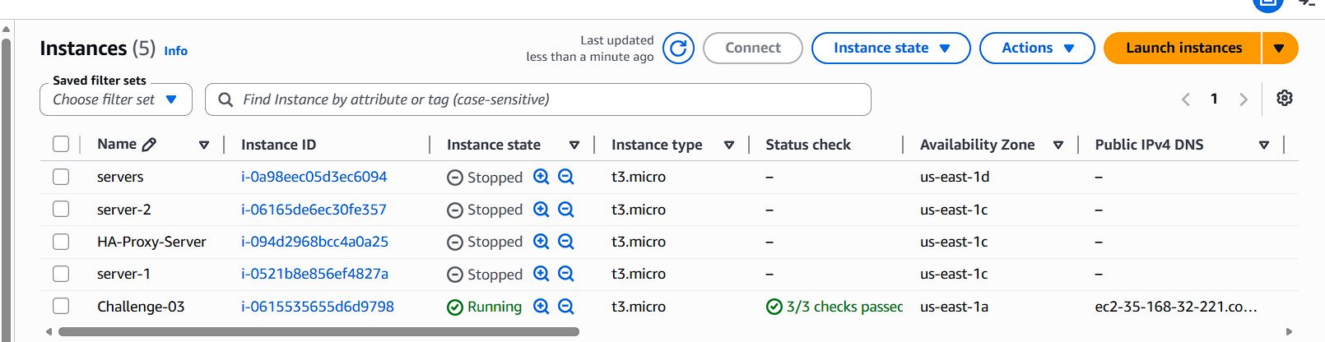
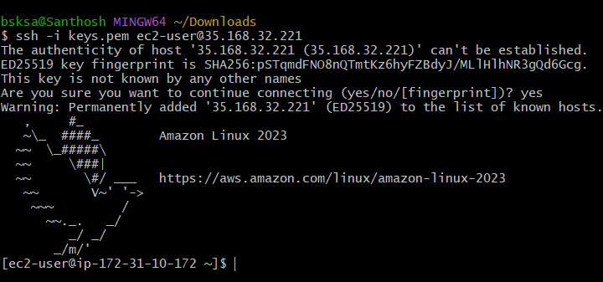
====================================================
Install Docker.
- Sudo yum install update -y
- Sudo yum install docker -y
- Sudo systemctl start docker
- Sudo systemctl enable docker
- Docker –version
- Sudo docker run hello world
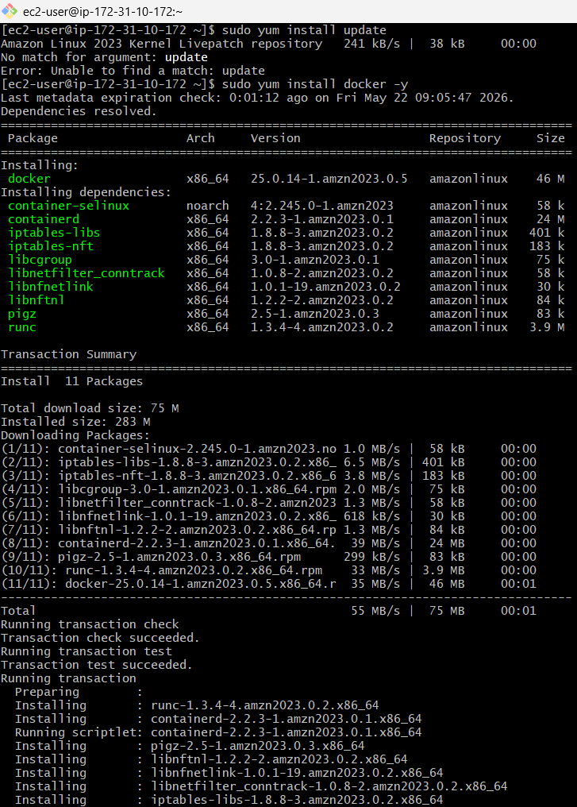
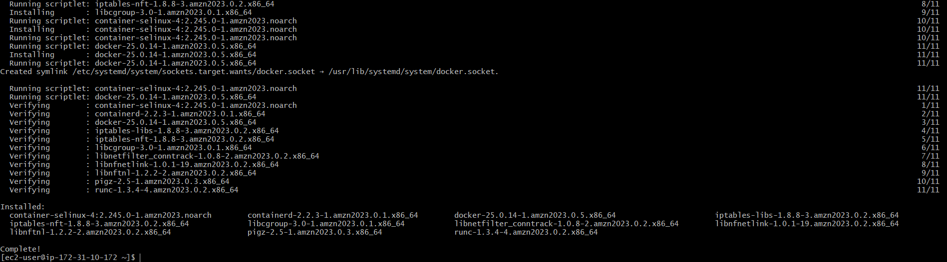
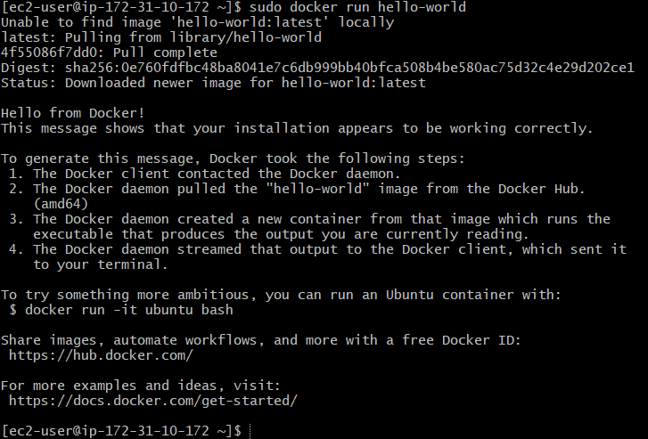
==================================================

Install Jenkins.
- Sudo yum install java-21 -y
- sudo wget -O /etc/yum.repos.d/jenkins.repo \https://pkg.jenkins.io/redhat-stable/jenkins.repo
- sudo rpm --import https://pkg.jenkins.io/redhat-stable/jenkins.io-2023.key
- Sudo yum install Jenkins -y
- Sudo systemctl start Jenkins
- Sudo systemctl status jenkins
- Copy the password from the give path to unlock Jenkins
- Select suggested installs
- Add username, password and email detail
- Click on save next and user is navigated to Jenkins dashboard.
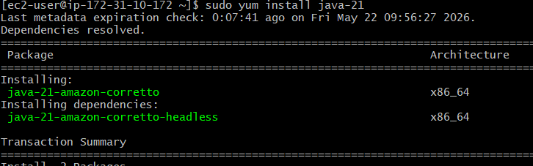
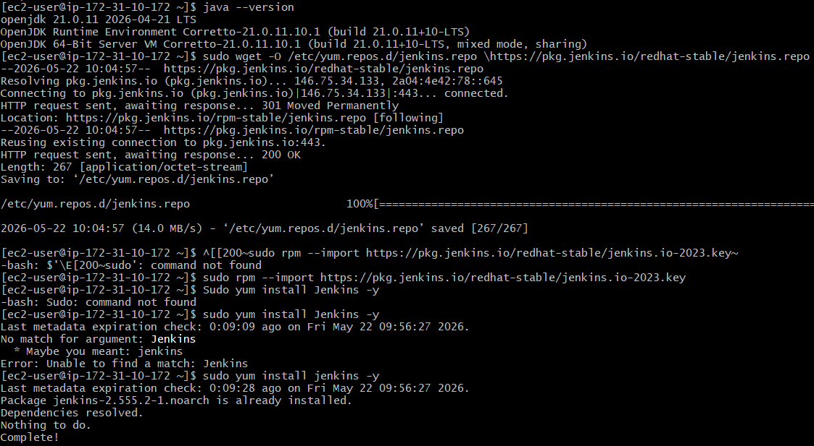
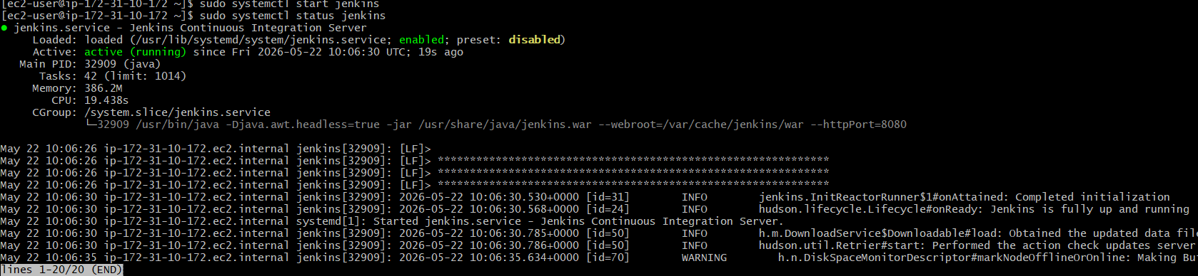
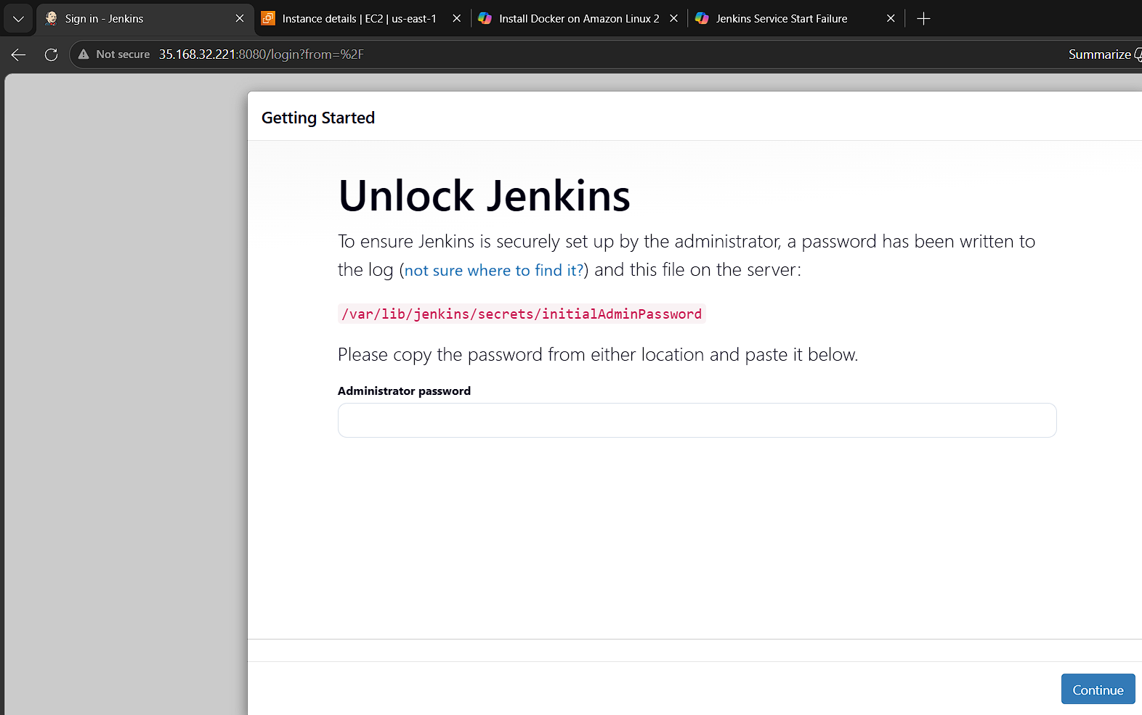
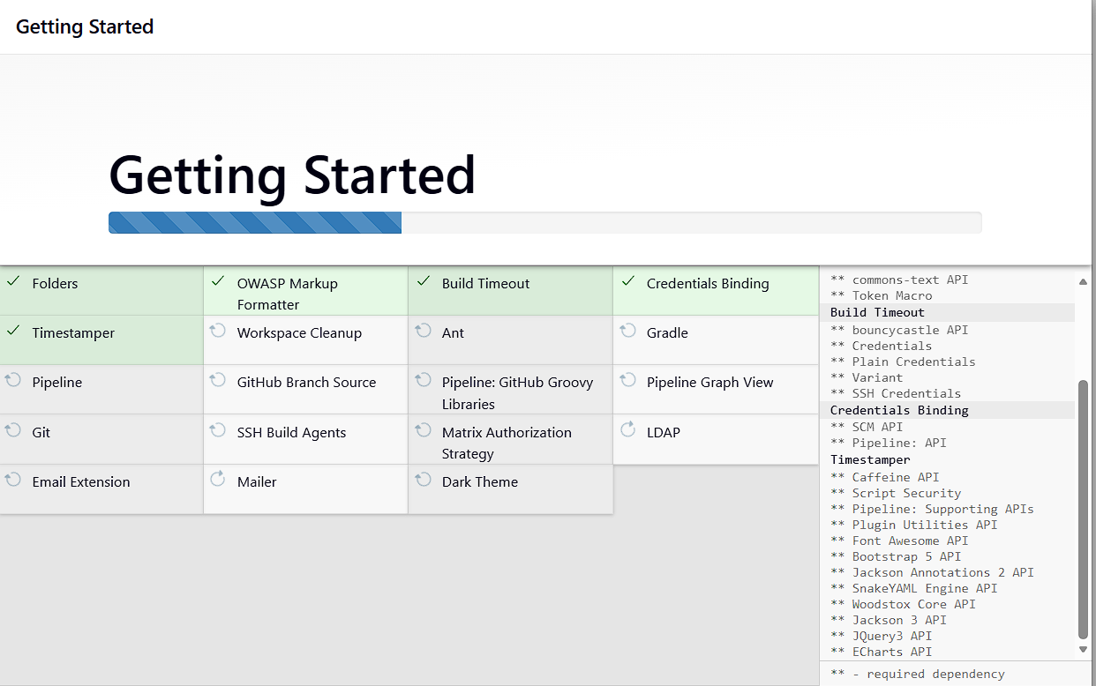
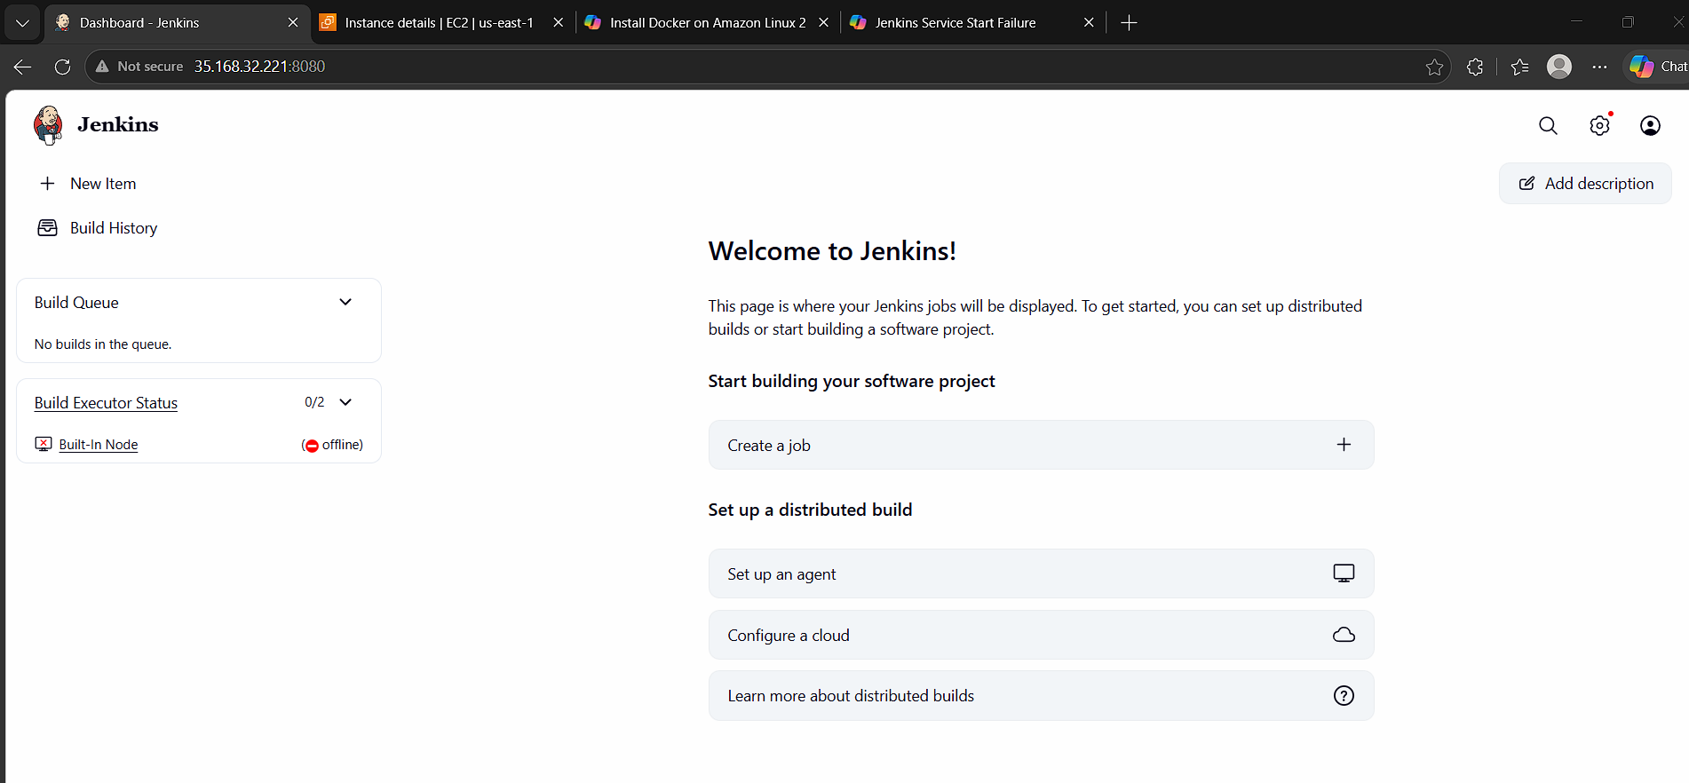

========================================================
Install Apache.
- Sudo yum install httpd -y
- Sudo systemctl start httpd
- Sudo systemctl enable httpd
- Sudo systemctl status httpd
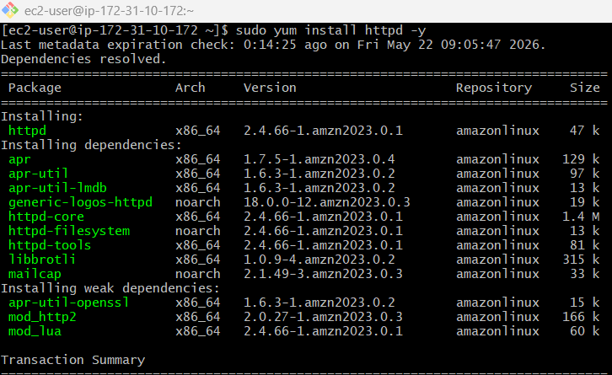
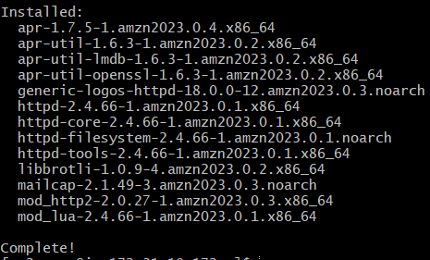
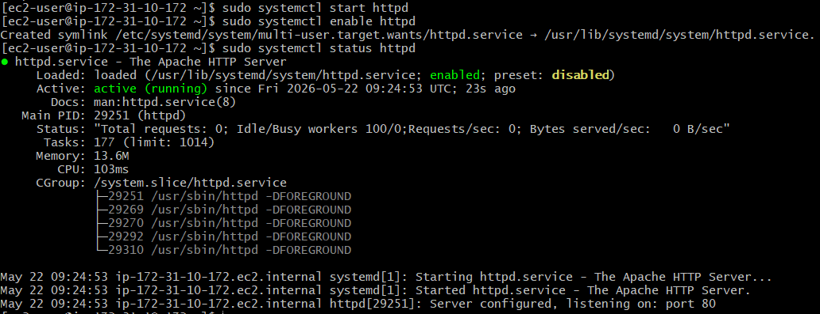
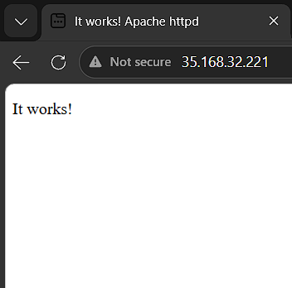
========================================================

Install Nginx.
- Sudo yum install nginx -y
- Sudo systemctl start nginx
- Sudo systemctl enable nginx
- Sudo systemctl status nginx
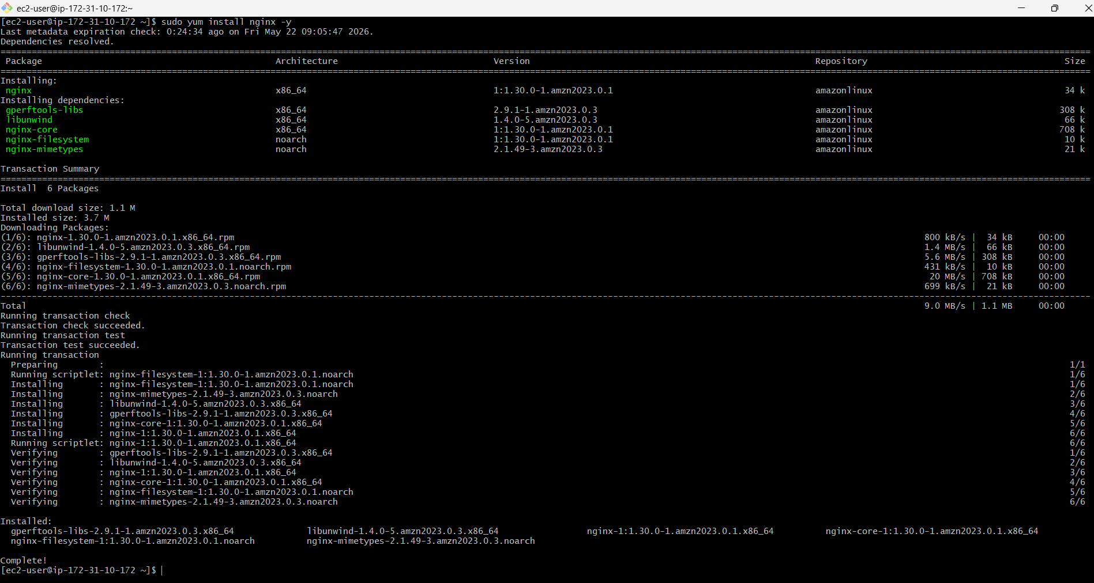
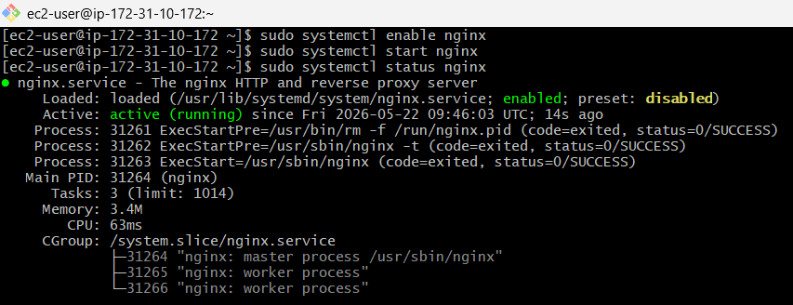
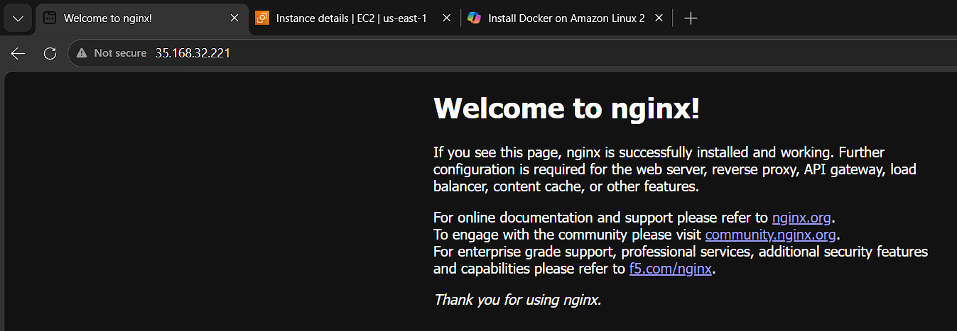

======================================================

Install Apache Tomcat.
- Wget https://dlcdn.apache.org/tomcat/tomcat-9/v9.0.118/bin/apache-tomcat-9.0.118.tar.gz
- Tar xvf apache-tomcat-9.0.118.tar.gz
- Mv apache-tomcat-9.0.118.tar.gz tomcat
- Make sure the jave-17 is installed
- Open vi /etc/systemd/system/tomcat.service
[Unit]
Description=Apache Tomcat Web Application Container
After=network.target

[Service]
Type=forking

Environment=JAVA_HOME=/usr/lib/jvm/java-17-amazon-corretto.x86_64
Environment=CATALINA_HOME=/opt/tomcat
Environment=CATALINA_BASE=/opt/tomcat
Environment=CATALINA_PID=/opt/tomcat/temp/tomcat.pid

ExecStart=/opt/tomcat/bin/catalina.sh start
ExecStop=/opt/tomcat/bin/catalina.sh stop

User=root
Group=root
Restart=always

[Install]
WantedBy=multi-user.target

- Systemctl daemon-reload
- Systemctl enable tomcat
- Systemctl start tomcat
- Systemctl status tomcat

